Chapter 7, Problem 62.

For the circuit in Fig. 7.127, calculate i(t) if i(0) = 0.

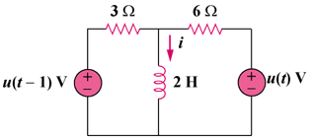

Figure 7.127
For Prob. 7.62.

